
SRM Institute of Science and Technology
Mode of Exam
OFFLINE
College of Engineering and Technology
School of Computing
(Common to all Branches)
DEPARTMENT OF COMPUTING TECHNOLOGIES
SRM Nagar, Kattankulathur – 603203, Chengalpattu District, Tamilnadu
Academic Year: 2023-24 (ODD)
Test: CLAT-1 Date: 18-08-2023
Course Code & Title: 21CSS201T COA Duration: 100 minutes
Year & Sem: II & III SET D Max. Marks: 50

Course Articulation Matrix:

Course Learning Outcomes (CLO) | At the end of this course, learners will be able to: | PO 1 | PO 2 | PO 3 | PO 4 | PO 5 | PO 6 | PO 7 | PO 8 | PO 9 | PO 10 | PO 11 | PO  12
CO-1 | Identify the computer hardware and how software interacts with computer hardware | H | M | - | - | - | - | - | - | - | - | - | -
CO-2 | Apply Boolean algebra as related to designing computer logic ,through simple combinational and sequential logic circuits | H | H | - | - | - | - | - | - | - | - | - | -

Part – A
(10 x 1 = 10 Marks)
Instructions: Answer all
Q. No | Question |  | Marks | BL | CO | PO | PI Code
1. | Which of the following is true about Computer Architecture?  - It acts as the interface between hardware and software.  - Computer Architecture tells us how exactly all the units in the system are arranged and interconnected.  - Computer Architecture is concerned with the structure and behaviour of a computer system as seen by the user.  - It involves Physical Components  ANS: a) and b) |  | 1 | 1 | 1 | 2 | 2.1.2
2 | Which among the following is a type of architecture used in the computers nowadays?  a) Microarchitecture  b) Harvard Architecture  c) Von-Neumann Architecture  d) System Design  ANS: c) |  | 1 | 1 | 1 | 2 | 2.1.2
3 | In which of the following form the computer stores its data in memory?  - Hexadecimal form  - Octal form  - Binary form  - Decimal form  ANS : c) |  | 1 | 2 | 1 | 2 | 2.1.2
4 | The two’s complement in binary system is useful for expressing  (A) Decimal numbers  (B) Positive numbers  (C) Negative numbers  (D) Binary numbers  ANS: c) |  | 1 | 2 | 1 | 2 | 2.1.2
5 | The parity bit is added for the purpose of ___________?  (A) Control key  (B) Error detection  (C) Indexing  (D) Coding  ANS: B) |  | 1 | 3 | 1 | 2 | 2.1.2
6 | Gray codes are used for?  a) To count the no of bits changes  b) To rotate a shaft  c) Error correction  d) Error Detection  ANS : c) |  | 1 | 2 | 1 | 2 | 2.1.3
7 | ASCII codes are required for representing more than ___ characters.  - 16  - 8  - 32  - 64  ANS: d) |  | 1 | 1 | 1 | 2 | 2.1.3
8 | Which of the following building block can be used to implement any combinational logic circuit?  - AND  - OR  - NAND  - XOR  ANS:c) |  | 1 | 3 | 1 | 2 | 2.1.2
9 | _______ points to the next instructions that are to be fetched from memory.  - Instruction register  - Program counter  - Memory Address Register  - Memory Data Register  ANS: b) |  | 1 | 2 | 2 | 2 | 2.1.2
10 | Consider a CPU that has 64- bit, the address of the contents are 1000, 1008, 1016, 1024. Now MAR is holding an address is 1008 to fetch the content from the memory. Analyze the operation and select the following address of the content which is held by the Program Counter (PC).  - 1000  - 1008  - 1016  - 1024  ANS: c) |  | 1 | 2 | 2 | 1 | 2.1.2
Part – B
( 4 x 4 = 16 Marks)
Instructions: Answer any 4
16 |  | Imagine you're participating in a coding competition, and one of the challenges involves working with binary and gray codes. In a particular round, you're given the binary code 100110 and asked to calculate its corresponding gray code. Can you perform the necessary steps to convert this binary code into a gray code?  ANS: 110101  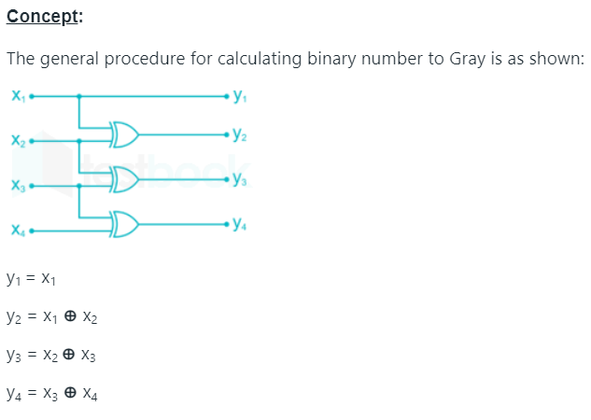 | 4 | 2 | 1 | 2 | 2.1.2
17 |  | Convert (6AF)₁₆ to binary and decimal.  ANS:  (6AF)₁₆ = (011010101111)₂  (6AF)₁₆ = (1711)₁₀ | 4 | 2 | 1 | 2 | 2.4.1
18 |  | Add the numbers 984.6 and 588.3 using BCD Addition method.  0001 0101 0111 0011.1001  So final answer of BCD addition is (1572.9) _{BCD} | 4 | 2 | 1 | 2 | 2.4.1
  Carry | 11
  BCD code for 984.6 : | 1001 | 1000 | 0100 | . 0110
  BCD code for 599.3 : | 0101 | 1000 | 1000 | . 0011
  Carry |  | 1 | 1
  Addition : | 1111 | 0000 | 1100 | . 1001
  If Invalid BCD then add 6 : | 0110 | 0110 | 0110
  Addition : | 1) 0101 | 0111 | 0010 | . 1001
19 |  | Imagine you're a computer science professor teaching memory addressing techniques. Covering byte address assignment, you use visuals to explain different approaches. Illustrate and explain these approaches with diagrams, aiding students' understanding of memory organization.  ANS:  Little-Endian:  In little-endian byte order, the least significant byte (LSB) is stored at the lowest memory address, while the most significant byte (MSB) is stored at the highest memory address.  Memory Address: | 0 | 1 | 2 | 3 |  Data (4 bytes): | 0x78 | 0x56 | 0x34 | 0x12 |  The least significant byte (0x12) is stored at the lowest memory address (0).  The most significant byte (0x78) is stored at the highest memory address (3).  Big-Endian:  In big-endian byte order, the most significant byte (MSB) is stored at the lowest memory address, while the least significant byte (LSB) is stored at the highest memory address.  Memory Address: | 0 | 1 | 2 | 3 |  Data (4 bytes): | 0x12 | 0x34 | 0x56 | 0x78 |  The most significant byte (0x12) is stored at the lowest memory address (0).  The least significant byte (0x78) is stored at the highest memory address (3). | 4 | 2 | 2 | 1 | 2.1.3
20 |  | Which part of the functional unit of the computer is known as “Brain” ? Justify  your answe  Which part of the functional unit of the computer is known as “Brain”? Justify your answer  ANS:  The part of the functional unit of the computer that is often referred to as the "Brain" is the Central Processing Unit (CPU). The CPU is justified as the brain due to its role in executing instructions, performing calculations, making decisions, and coordinating all essential tasks within the computer. Similar to how the brain processes information, the CPU manages data flow, controls memory access, and carries out arithmetic and logic operations. Just as the brain is central to human decision-making and control, the CPU plays a pivotal role in the overall functioning and operation of a computer system. | 4 | 2 | 2 | 1 | 2.1.3
PART C

( 12 x 2 = 24 Marks)
Instructions: Answer all
21 | - Convert the following.  - Convert Hexadecimal (A4B.59E) to the decimal form. (3)  ANS:  Decimal equivalent of the hexadecimal number A4B.59E is approximately 2635.3515625.  - Convert Excess-3 (011110100110) to binary (3)  ANS:  Step i) Convert XS-3 to Decimal  0111 1010 0110  7 10 6  -3 -3 -3  4 7 3  =(473)₁₀  Step ii) Convert Decimal to Binary  ANS: (111011001)₂  - Convert decimal (325.56)₁₀ to Excess-3. (3)  ANS: (011001011000.10001001)_{XS-3}  - Convert octal number 292.863 into binary number.  Kindly award marks for this if student attempted(3 marks)  [OR]  - i) Mention the two ways of representing signed numbers. Explain the 1’s and 2’s complement method of binary subtraction with appropriate examples. (6)  ANS:  Subtraction using 1’s complement: STEPS  - Obtain 1’s complement of subtrahend  - Add the result to minuend and call it intermediate result  - If carry is generated then answer is positive and add the carry to Least Significant Digit (LSD)  - If there is no carry then answer is negative and take 1’s complement of intermediate result and place negative sign to the result.  Example – 1:  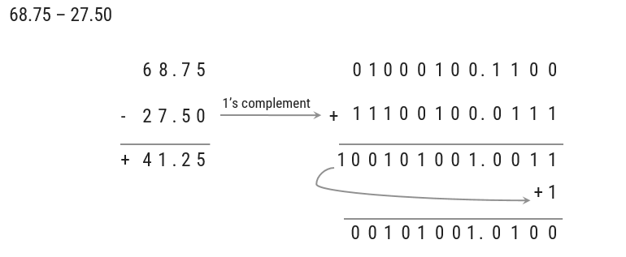  Example 2:  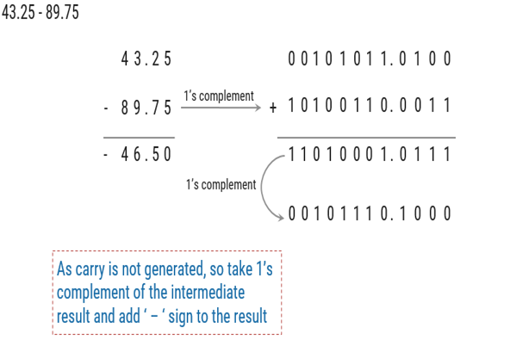  Subtraction using 2’s complement: STEPS  - Obtain 2’s complement of subtrahend  - Add the result to minuend  - If carry is generated then answer is positive, ignore carry and result itself is answer  - If there is no carry then answer is negative and take 2’s complement of intermediate result and place negative sign to the result.  Example 1:  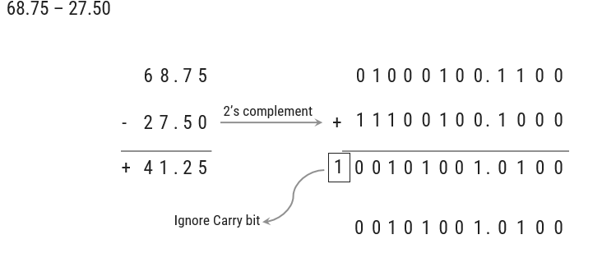  Example 2:  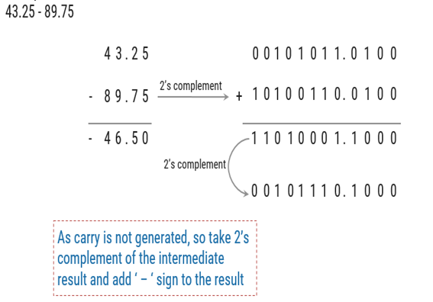  ii) Explain about BCD subtraction depicting both BORROW and NO BORROW condition. (6)  Binary-Coded Decimal subtraction refers to the process of subtracting two numbers that are represented in BCD format. BCD is a binary-encoded representation of decimal numbers, where each decimal digit is encoded using a 4-bit binary number. In BCD representation, each decimal digit (0-9) is represented by its 4-bit binary equivalent.  Rule: If one 4-bit group needs to take borrow from neighbour, then subtract 0110 from the group which is receiving borrow.  Example - 1  NO BORROW CONDITION  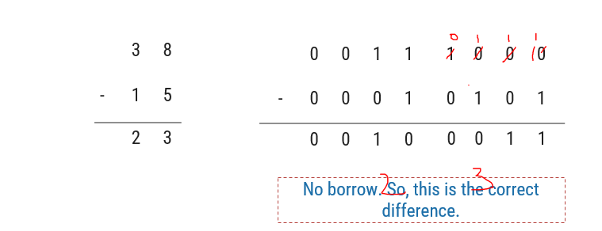  Example - 2  BORROW CONDITION  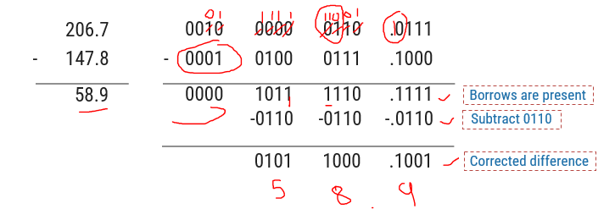 |  | 12 | 2 | 1 | 2 | 2.4.1
22 | - i) Imagine you are a computer systems architect working on designing a new computer system. Your team is discussing the architecture's components and their functions. Your colleague asks you to explain the practical applications of a bus structure in computer systems. Could you also outline the various types of bus structures and provide a visual representation of each type using diagrams? (8)  ANS:  BUS STRUCTURE (2 marks)  A Bus is a collection of wires that connects several devices. Buses are used to send control signals and data between the processor and other components. This is to achieve a reasonable speed of operation. In computer system all the peripherals are connected to microprocessor through Bus.  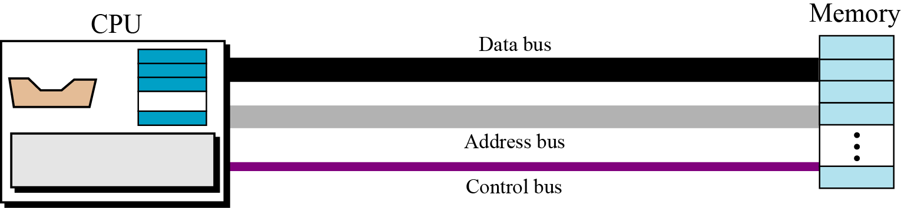  - 2³ = 8 i.e. 3 address line is required to select 8 location  - In general 2^{x} = n where x number of address lines (address bit) and n is number of location  - Address bus : unidirectional : group of wires which carries address information bits from processor to peripherals (16,20,24 or more parallel signal lines)  - Data bus: bidirectional : group of wires which carries data information bit form processor to peripherals and vice – versa  - Control bus: bidirectional: group of wires which carries control signals form processor to peripherals and vice – versa  TYPES (6- each 2 marks with diagram)  Types of Bus structure:  Single bus  Two-bus  Multi-bus  ii) Write the boolean expression for the output variable Q. (4)  .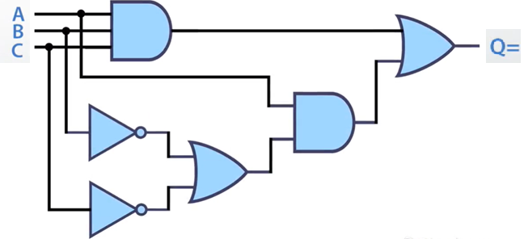  ANS: Q= A.B.C + A.(B’+C’)  [OR]  - (i) Imagine you are a computer architecture instructor and you're teaching a group of students about the fundamental concept of the instruction fetch technique in a processor. To help them grasp the process better, you decide to provide a clear visual representation. Could you illustrate the step-by-step process of the instruction fetch technique using a well-labeled diagram? 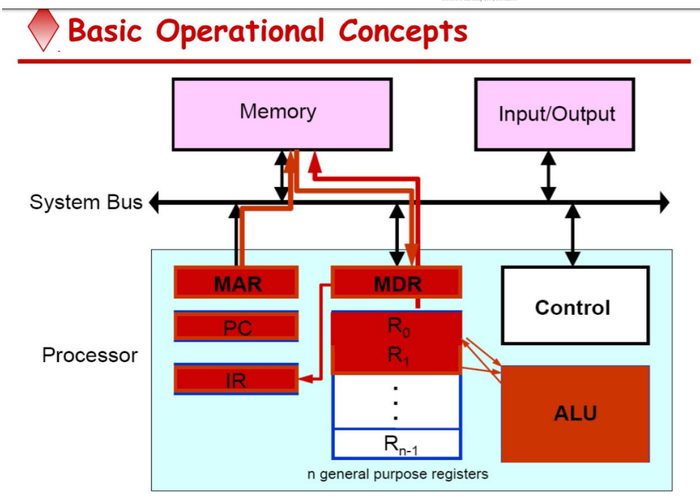  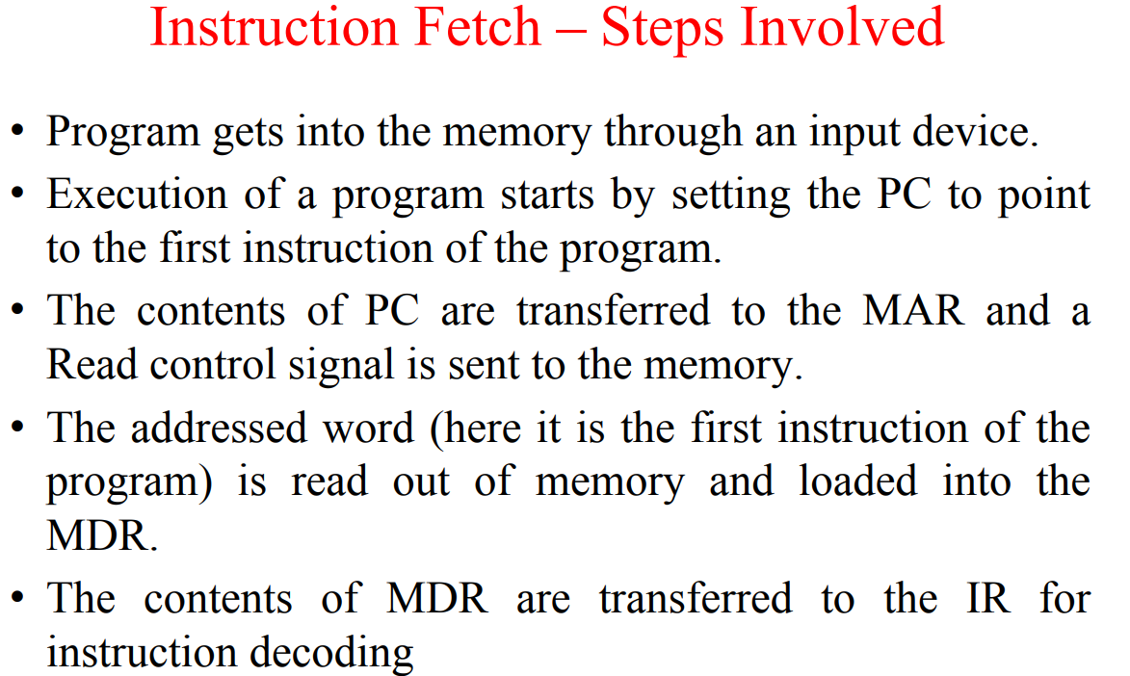  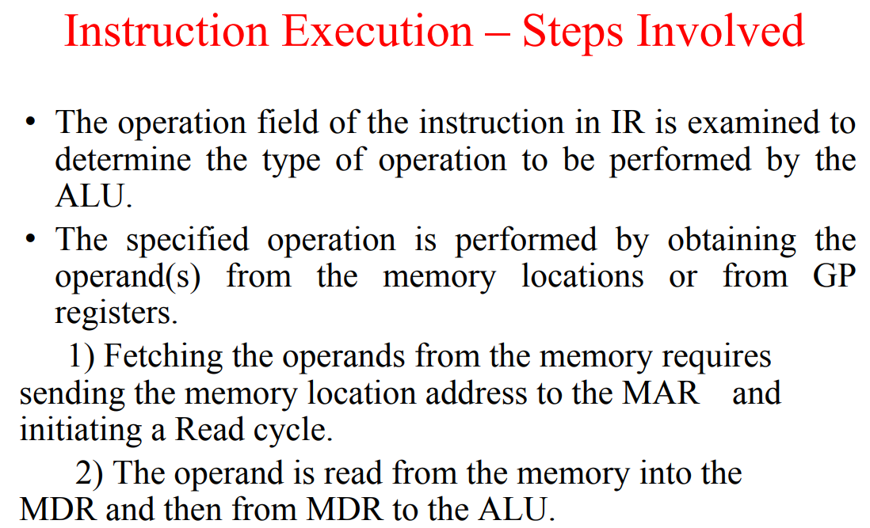  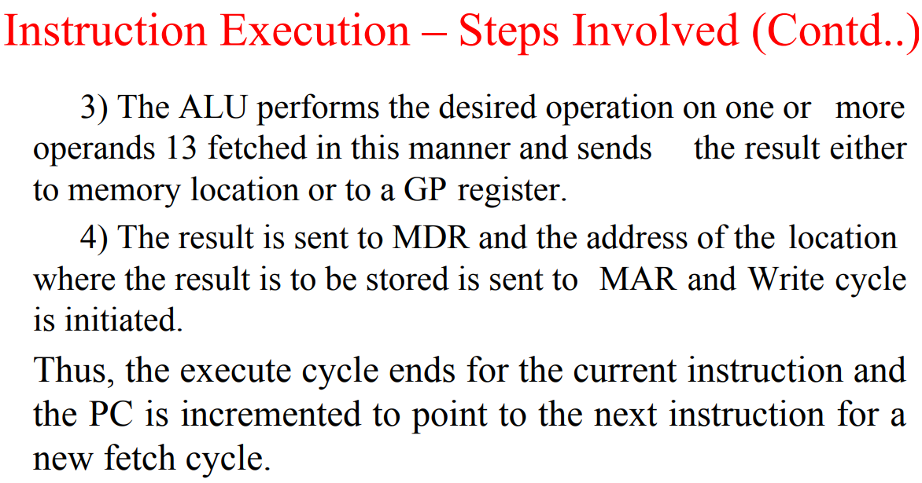  (6)  (ii) Imagine you are a computer hardware instructor, and you're leading a workshop on computer architecture for a group of enthusiastic students. To help them grasp the concept of how the processor communicates with memory in a computer system, you decide to provide a hands-on explanation. Could you sketch a diagram that illustrates the connections between the processor and memory components? Additionally, explain how data and instructions flow between these two vital components, highlighting the significance of this interaction in the overall functioning of a computer. (6)  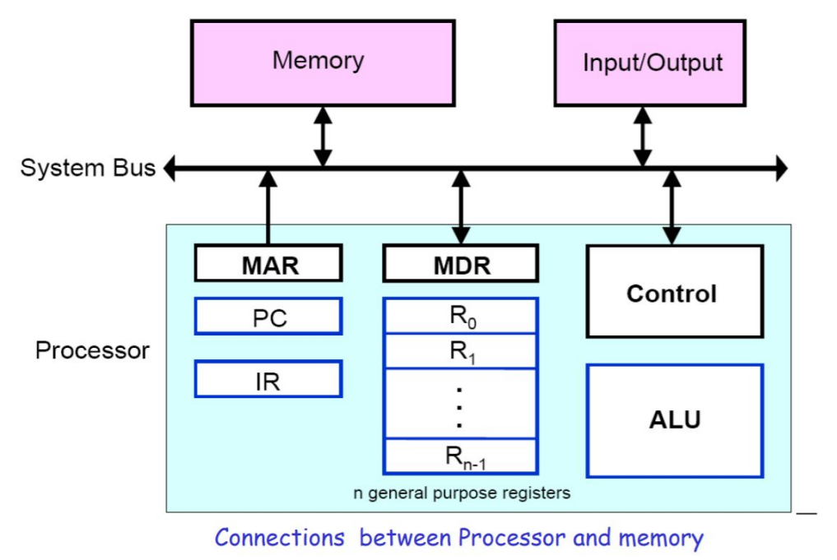  - Two registers-MAR (Memory Address Register) and MDR (Memory Data Register) : To handle the data transfer between main memory and processor. MAR-Holds addresses, MDR-Holds data  - Instruction register (IR) : Hold the Instructions that is currently being executed  - Program counter (PC) : Points to the next instructions that is to be fetched from memory  - General-purpose Registers: are used for holding data, intermediate results of operations. They are also known as scratch-pad registers.  Processor:  The processor consists of the Arithmetic Logic Unit (ALU) and the Control Unit (CU). The ALU performs arithmetic and logical operations, while the CU manages the execution of instructions.  Memory:  Memory components include Random Access Memory (RAM), Read-Only Memory (ROM), cache, and more. RAM is used for temporary data storage, while ROM holds permanent instructions. Cache is a faster, smaller memory used to store frequently accessed data for quicker retrieval.  Data Flow:  Instructions:  The Control Unit fetches instructions from memory. It sends a memory address to the memory module, requesting the instruction located at that address.  The instruction is fetched from memory and loaded into the Instruction Register (IR) within the CU.  The Control Unit decodes the instruction, determining the operation to be performed.  Data:  To perform operations, the ALU requires data. Data can be operands for arithmetic operations or values for logical operations.  The Control Unit provides memory addresses to fetch data from memory. Similar to fetching instructions, it sends the memory address to memory and retrieves the data.  Significance of Interaction:  The interaction between the processor and memory is crucial to a computer's operation:  Execution of Programs:  Programs consist of a series of instructions stored in memory. The processor fetches, decodes, and executes these instructions sequentially. The memory holds the program's instructions and data, allowing the processor to work on them.  Data Manipulation:  The processor performs calculations and manipulates data stored in memory. Data is fetched from memory, processed in the ALU, and the results are often stored back in memory.  Performance:  Efficient communication between the processor and memory is essential for optimal performance. Caches are used to store frequently accessed data, reducing the time needed to fetch data from main memory. |  | 12 | 2 | 2 | 2 | 2.4.1

*Performance Indicators are available separately for Computer Science and Engineering in AICTE examination reforms policy.

Course Outcome (CO) and Bloom’s level (BL) Coverage in Questions

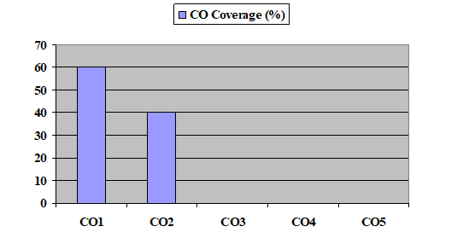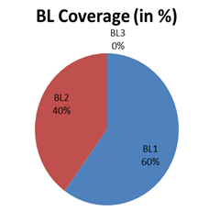

Approved by the Audit Professor/Course Coordinator

